Module Name: Practice Test Automation - Bugzilla & TestLink
Test Case ID: st_08
Webpage URL:https://practicetestautomation.com/logged-in-successfully

Scenario ID: 1a

Scenario: Login with valid credentials
Test Steps:
- Enter username
- Enter password
- Click Login
Screenshots:
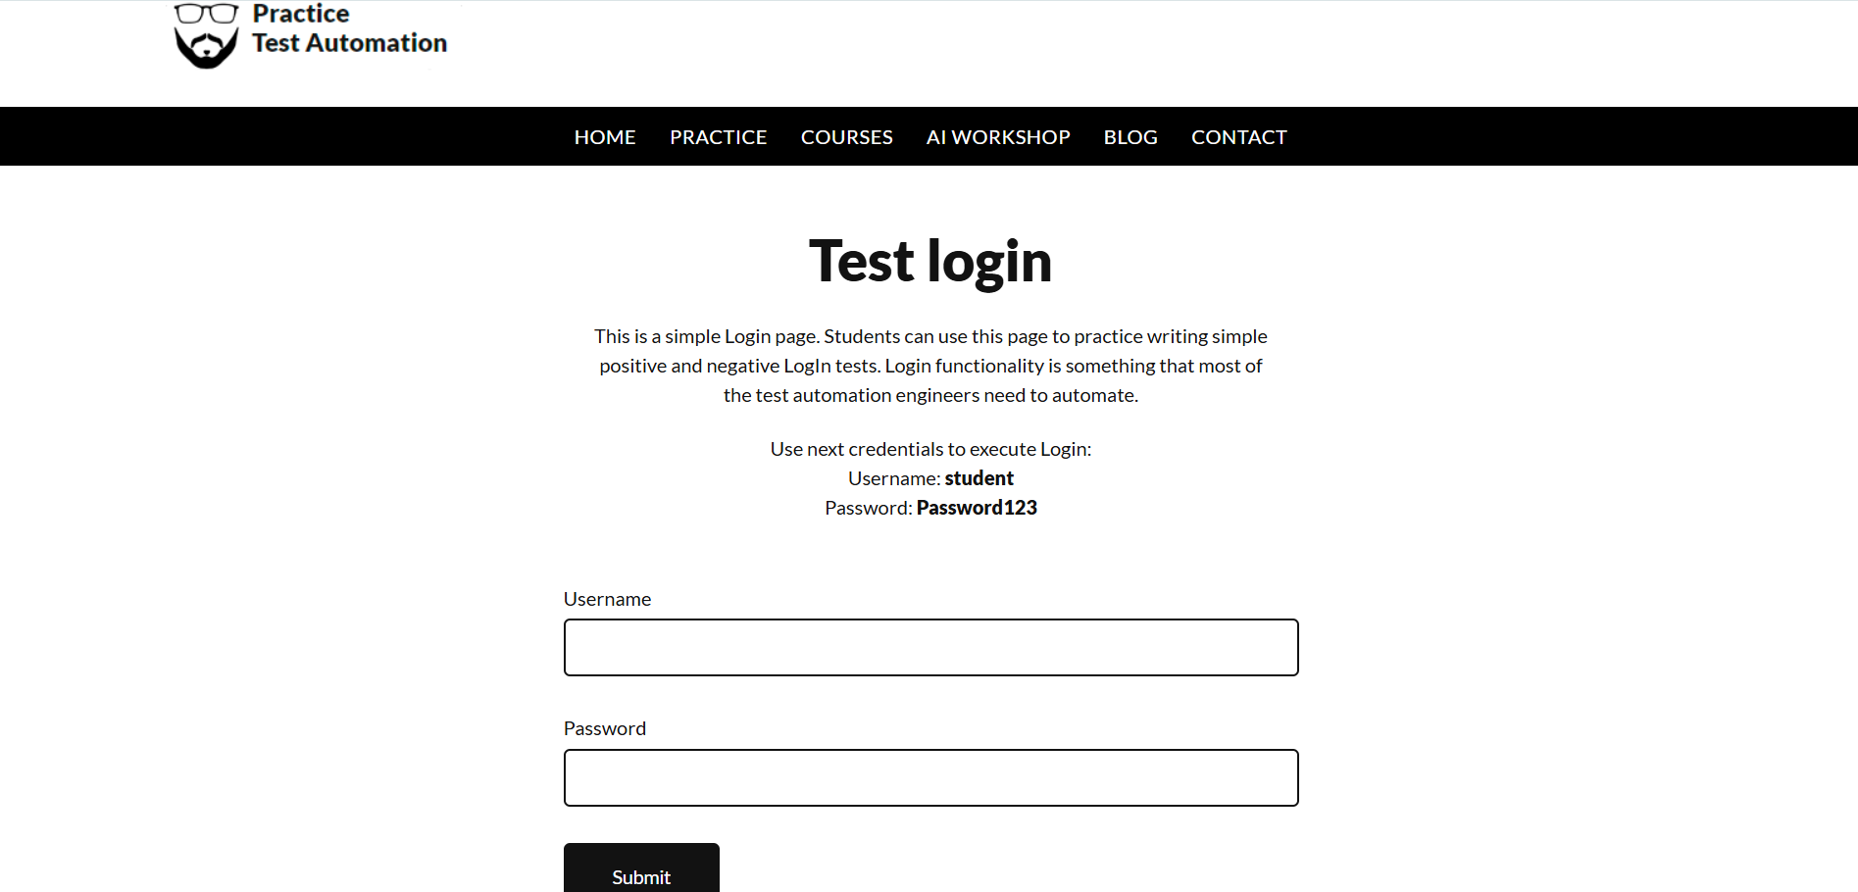
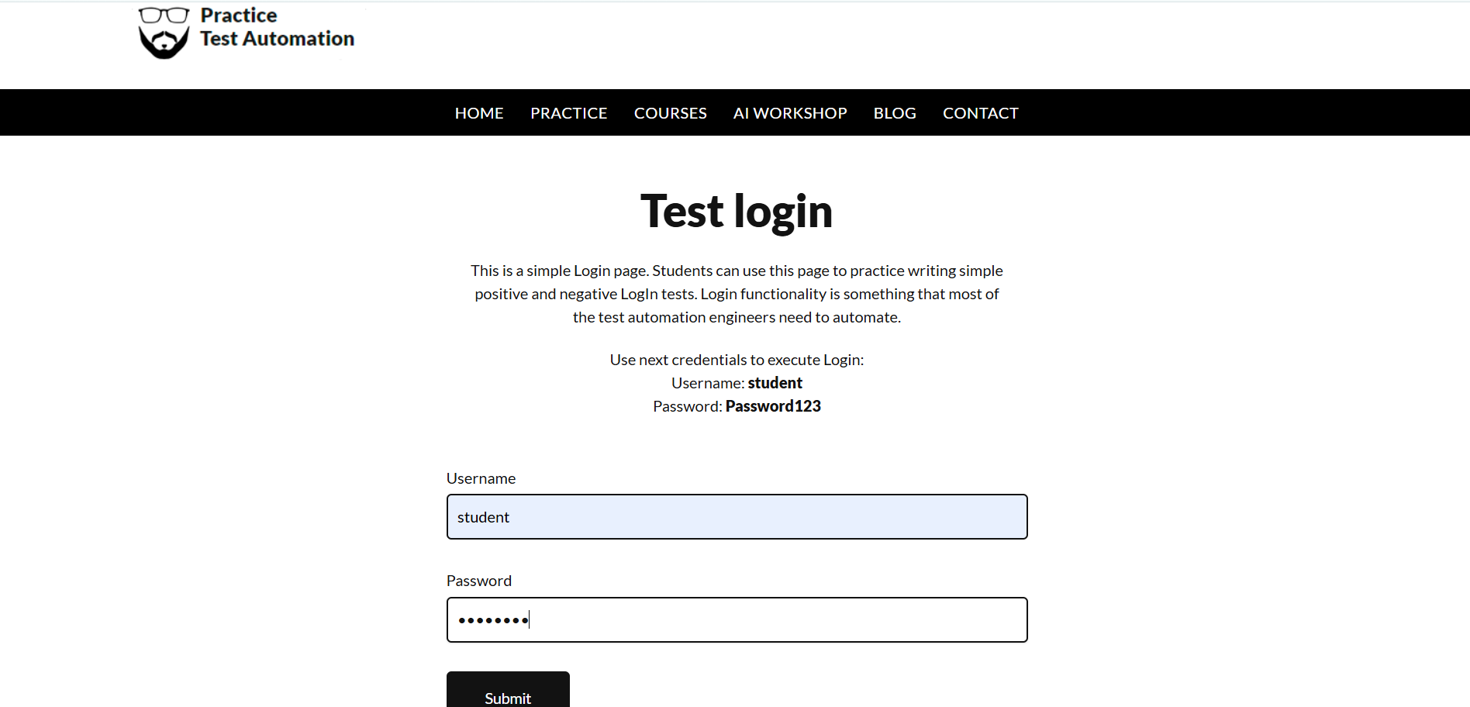
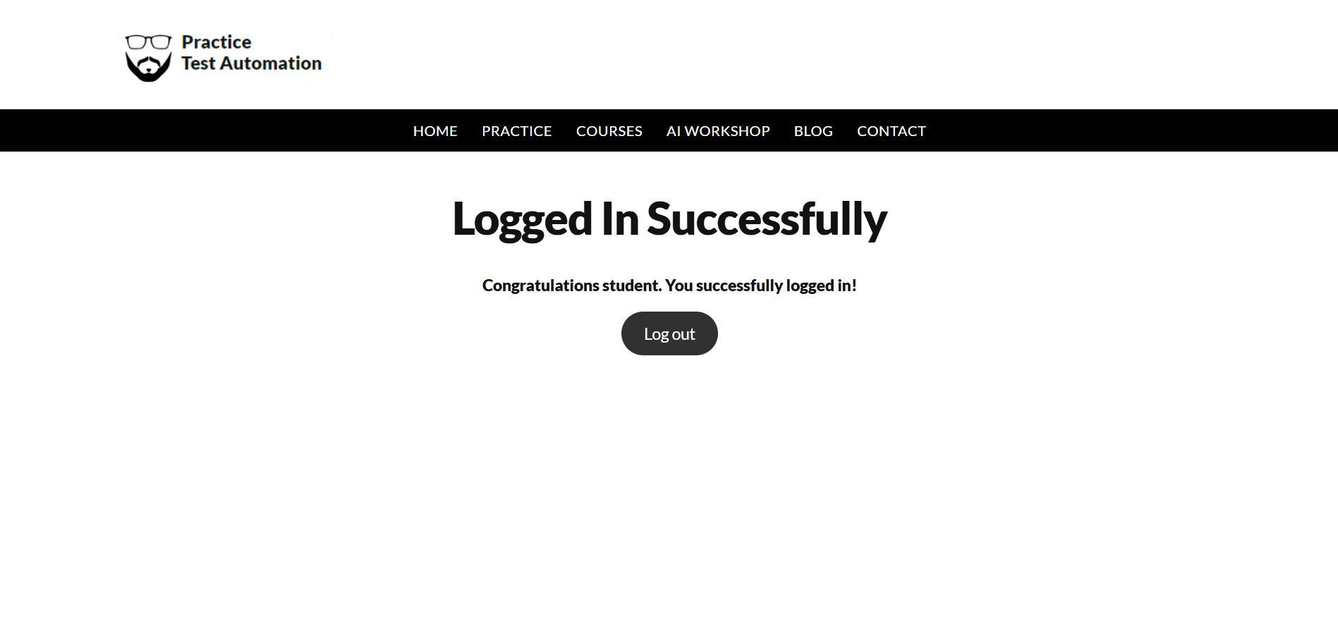
Actual Result :- Successful Login
Status:- Pass

Scenario ID: 2a

Scenario:view courses
Test Steps:
- Enter usename & password
- Click login
- Click courses
Screenshots:
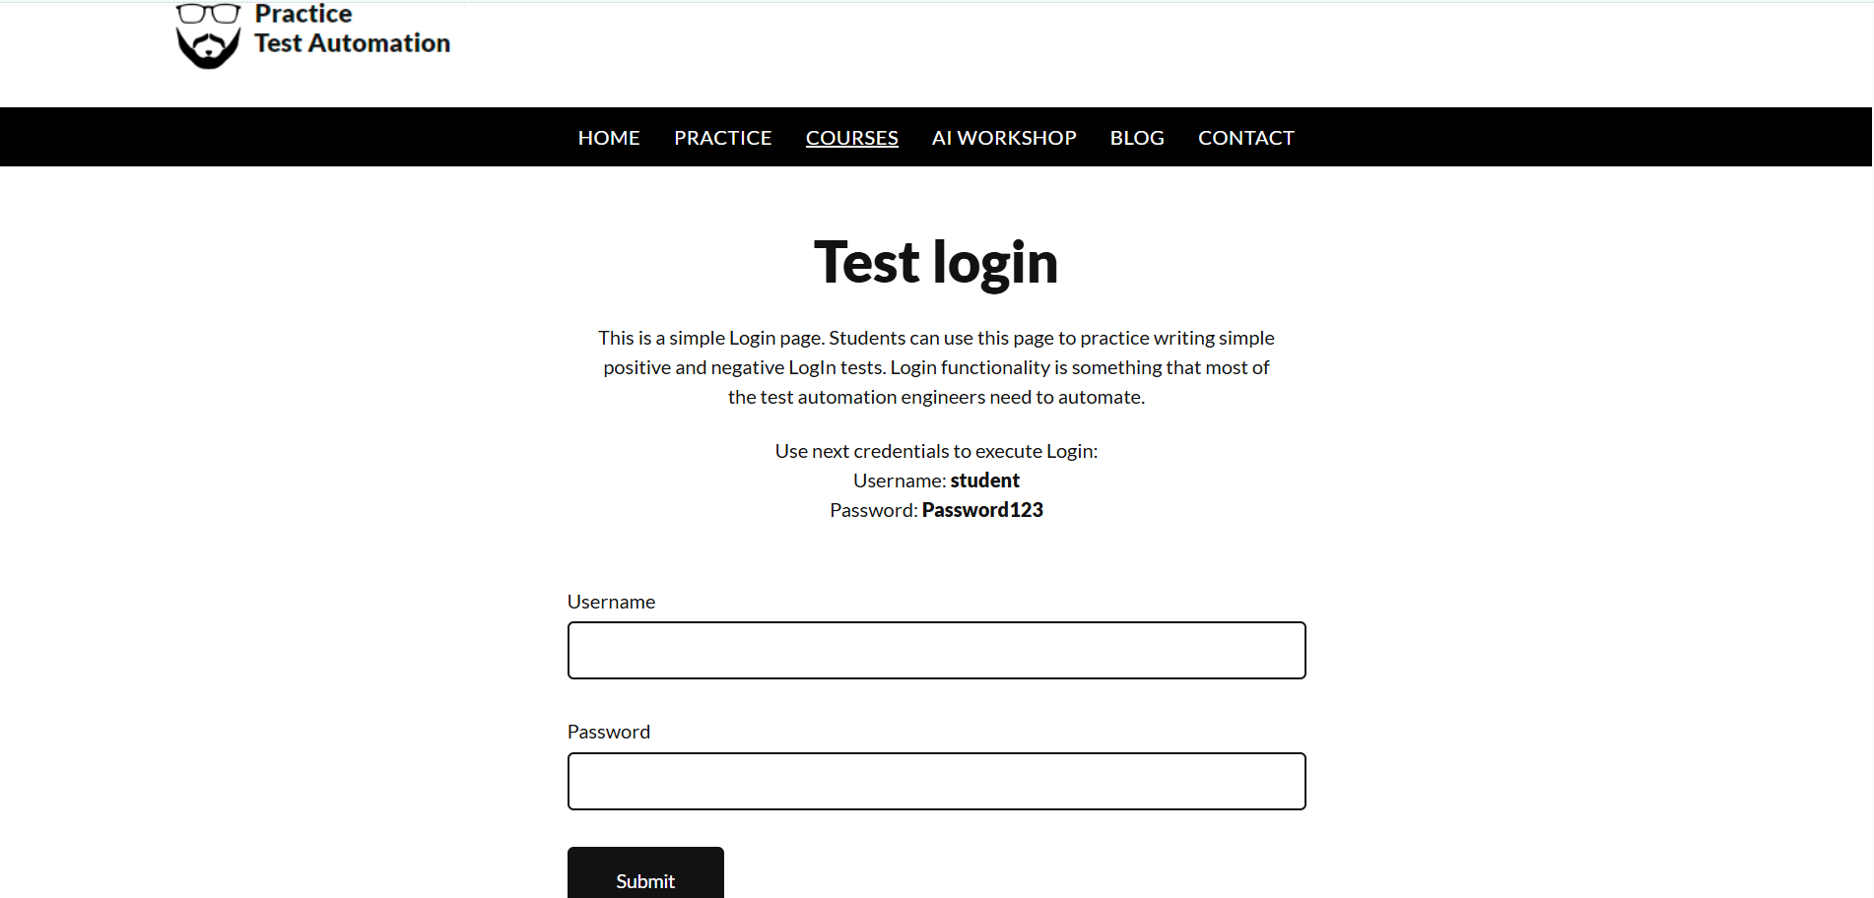
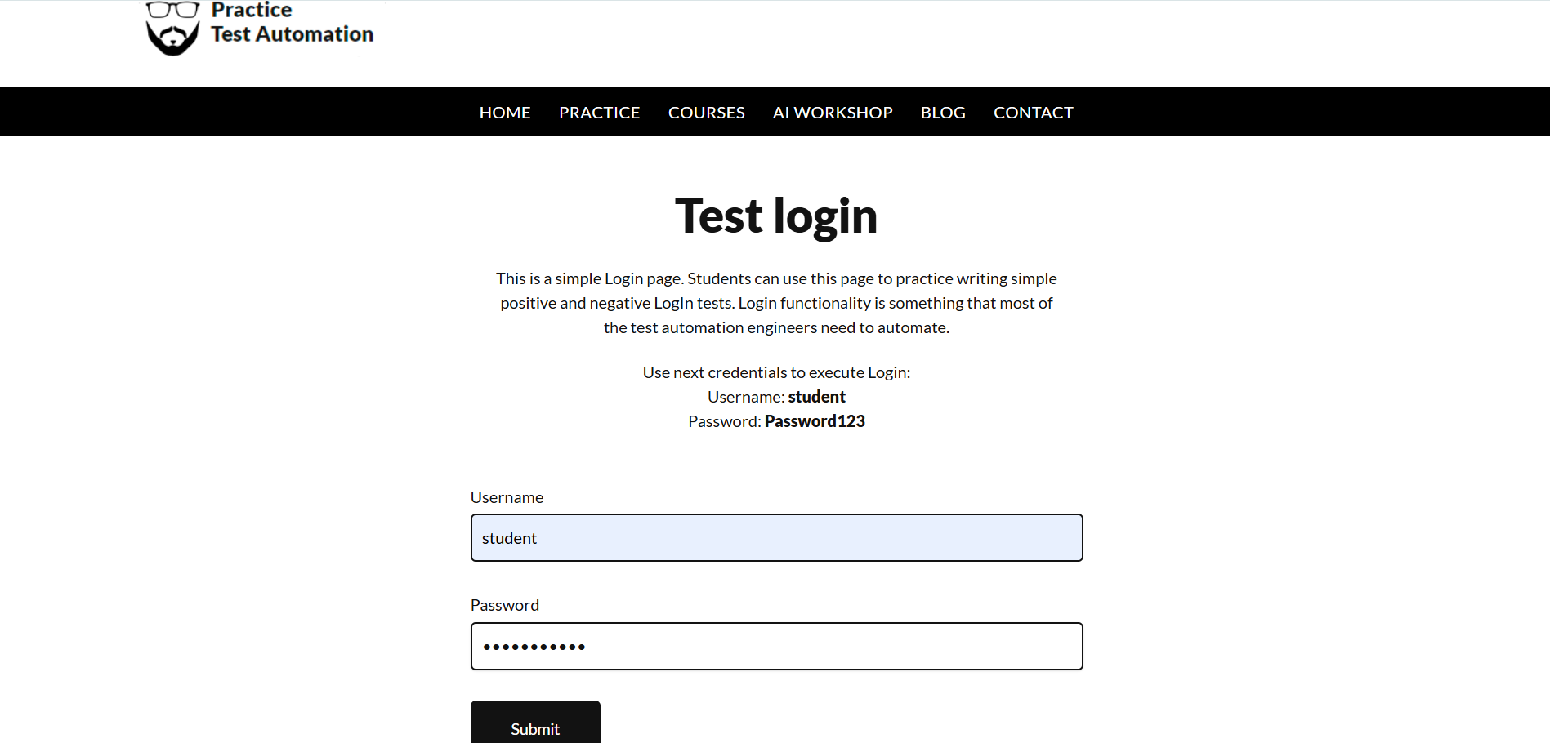
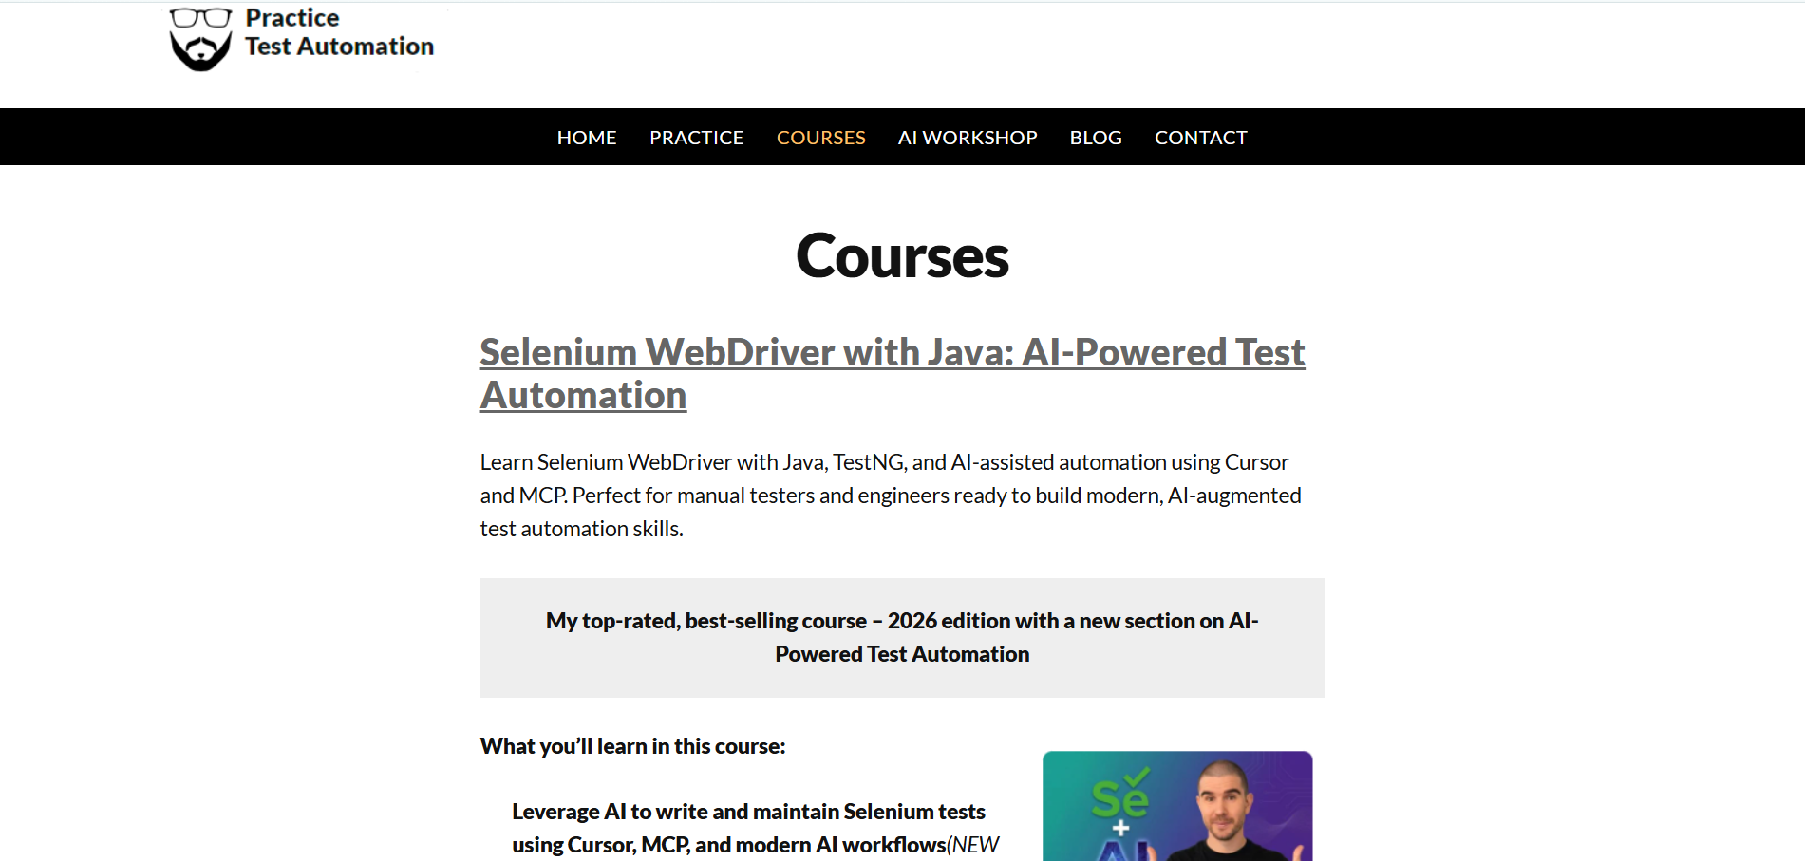

Actual Result :- Successfully view courses
Status:- Pass

Scenario ID: 2b

Scenario:Select courses
Test Steps:
- Enter usename & password
- Click login
- Click courses
- Select courses
Screenshots:

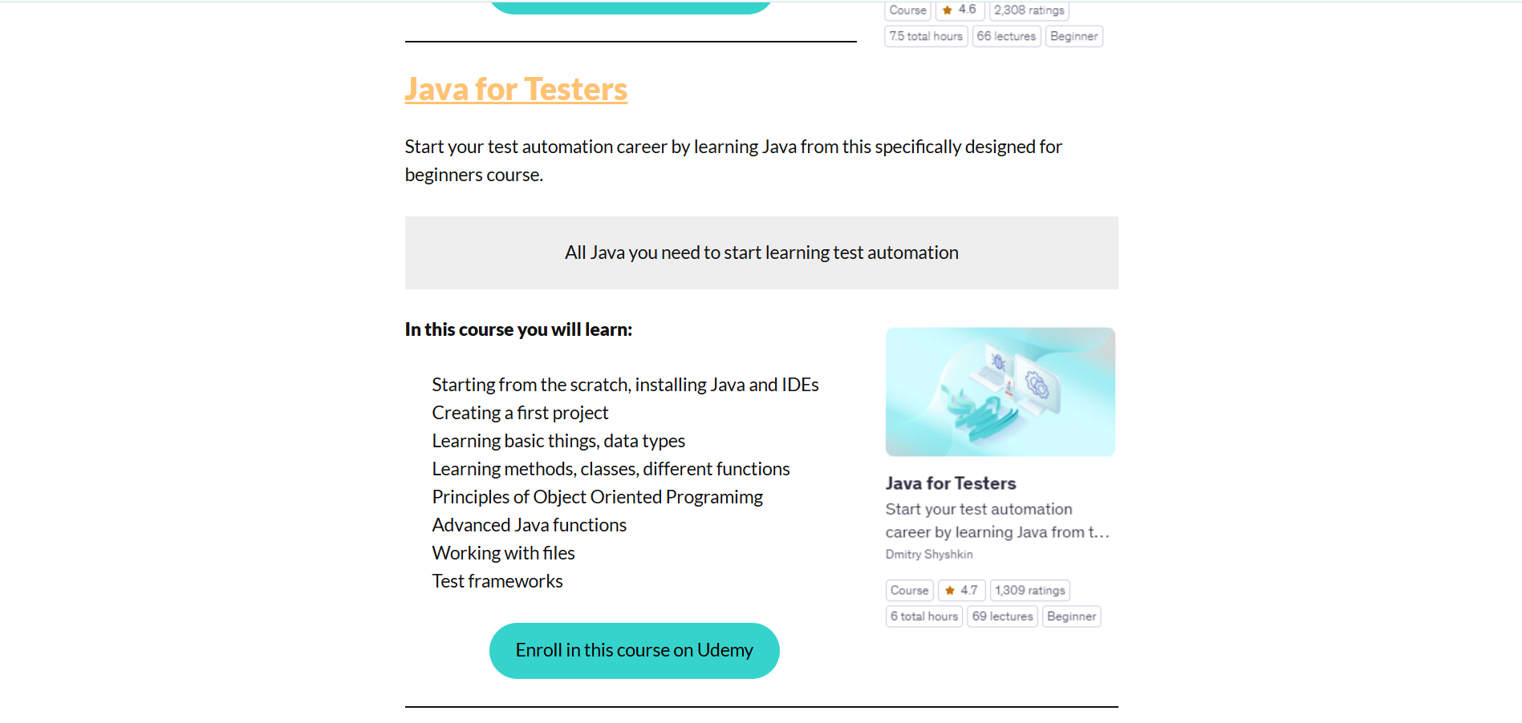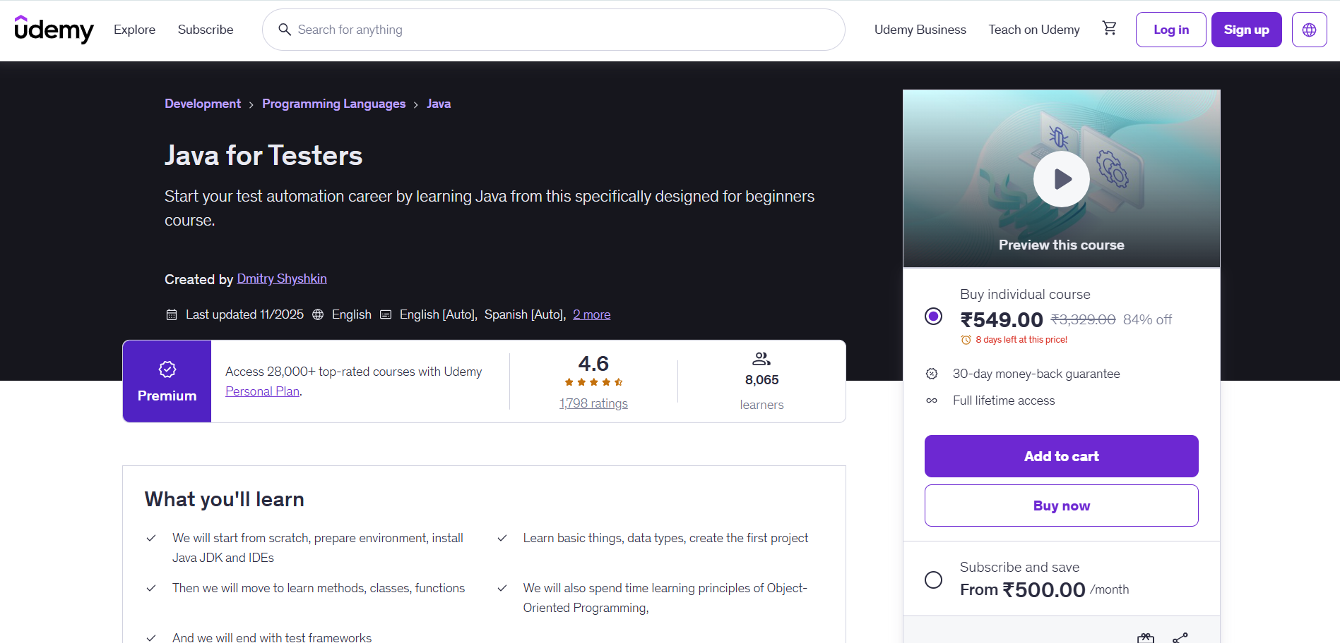

Actual Result :-Successfully select courses
Status:- Pass

Scenario ID: 2c

Scenario:view courses details
Test Steps:
- Enter usename & password
- Click login
- Click courses
- Select courses
- view courses details
Screenshots:

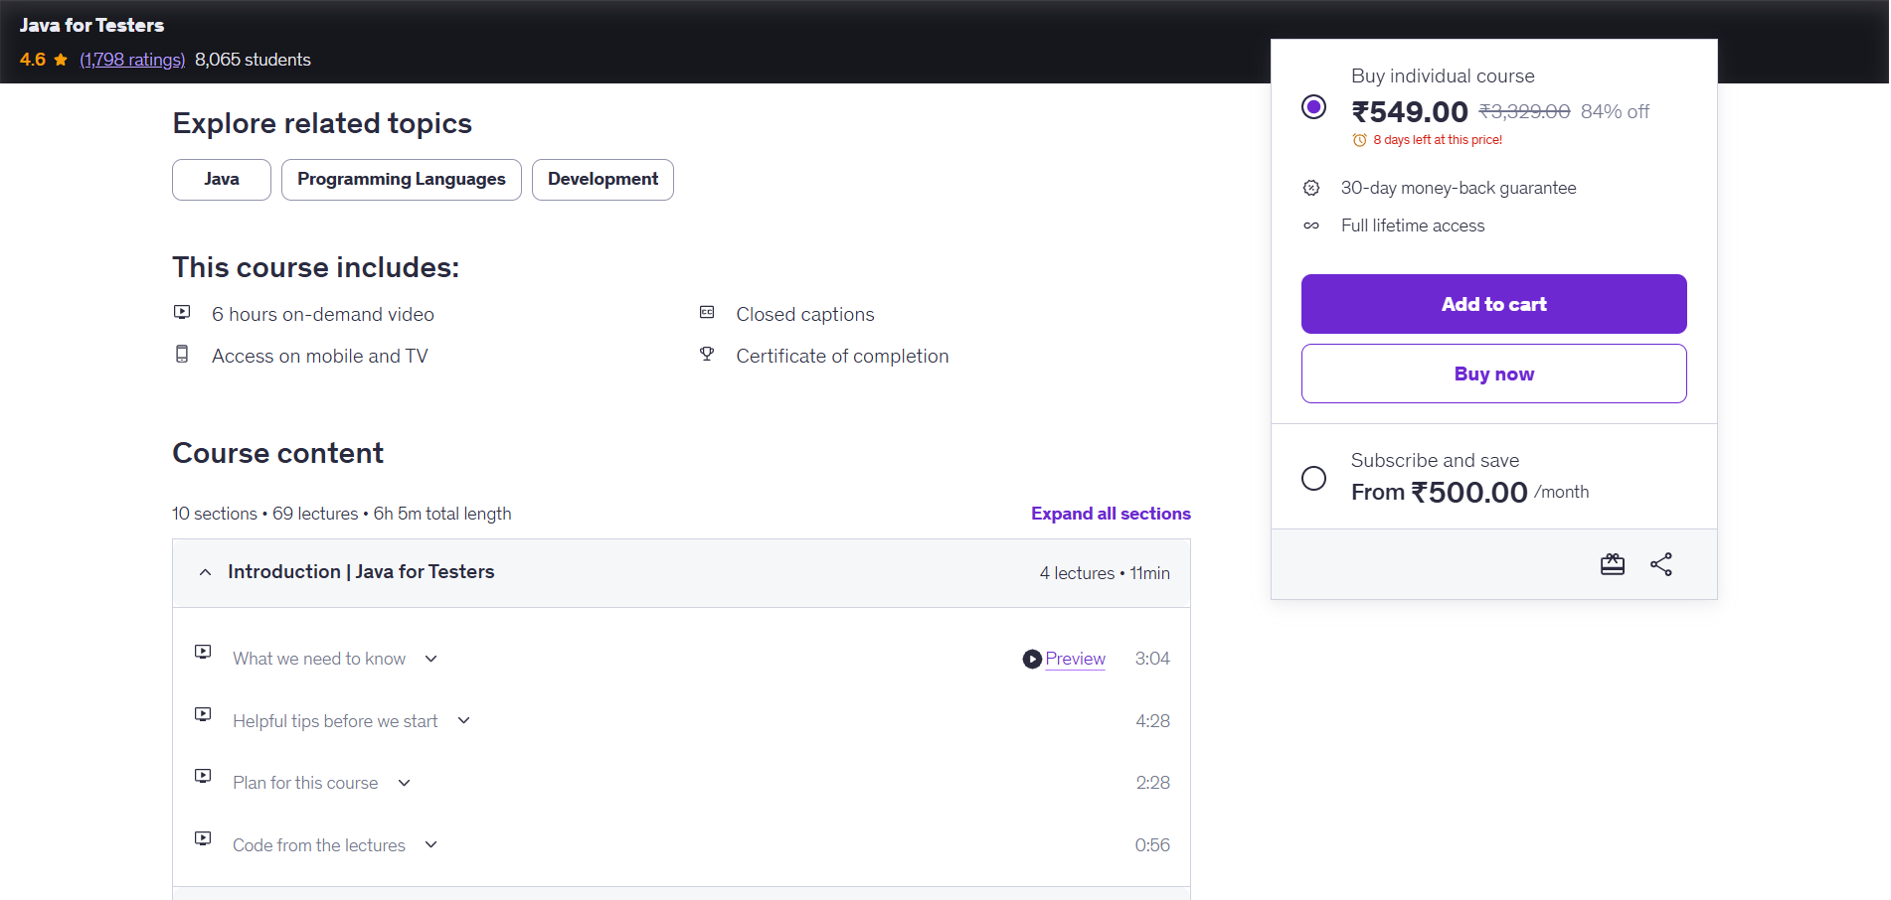

Actual Result :-Successfully view courses details
Status:- Pass

Scenario ID: 3a

Scenario:View cart
Test Steps:
- Enter usename & password
- Click login
- Click courses
- Select courses
- Click Cart
Screenshots:



Actual Result :-Successfully view cart
Status:- Pass

Scenario ID: 3b

Scenario:Add to cart
Test Steps:
- Enter usename & password
- Click login
- Click courses
- Select courses
- Add to Cart
Screenshots:

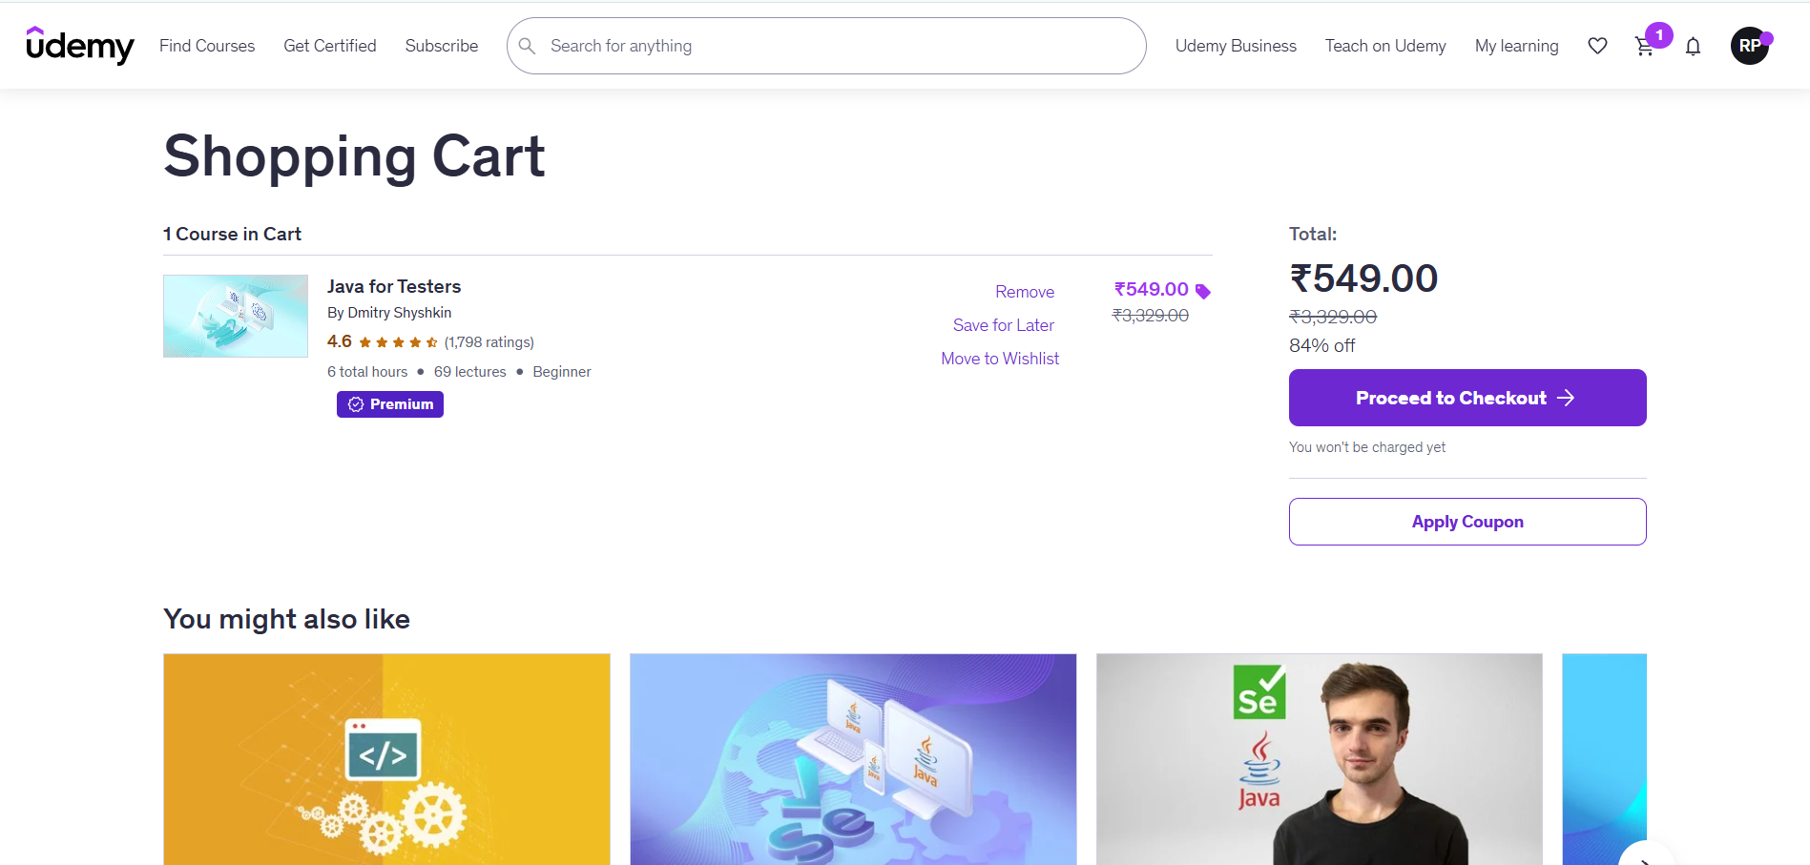

Actual Result :-Successfully Add to cart
Status:- Pass

Scenario ID: 4a

Scenario: Logout a website
Test Steps:
- Enter username
- Enter Password
- Click Login
- Click Logout
Screenshots:
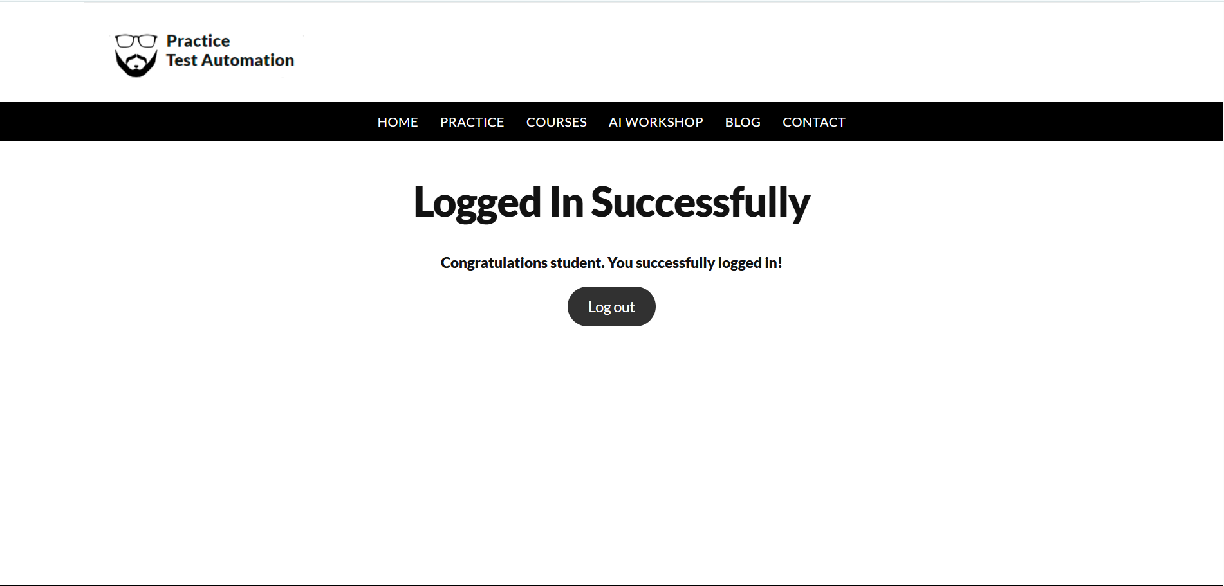

Actual Result :-Successfull Logout
Status:- Pass

